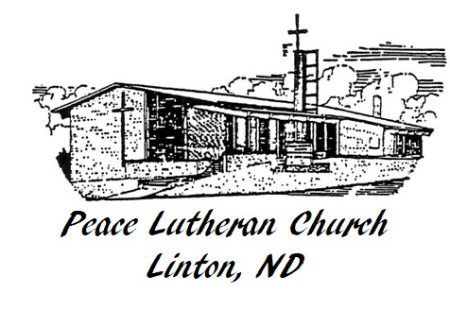
Pastor’s Article
PLC Newsletter
February 2026

Peace Lutheran Church
200 5th St. NE – PO Box 686
Linton, ND 58552

Sean Barnhart, Pastor
Twila Van Boven, Bookkeeper

Office: 701-254-5395
Email: peacelutheran@bektel.com

www.facebook.com/peacelutheranlinton
www.youtube.com/@peacelutheran1357
www.ndpeacelutheran.com



Proud member of the Northern Plains District of the LCMC

I’ve been thinking about heaven lately. More accurately, I’ve been thinking about how we think about heaven.

Often, when we think about heaven we think about the people we anticipate seeing there. We imagine happy reunions with grandparents who secretly pampered us without our parents’ knowing. Or we picture seeing that favorite aunt or uncle who had the biggest personality and was always good for a laugh. Of course, many of us long for an embrace with one who took more than a piece of our hearts with them when they left this earth.

Heavenly reunions are happy thoughts, but they are not the whole story. As far as I know, Scripture doesn’t actually speak of such reunions. Instead, Scripture speaks of a reconciliation between sinners and the Lord bought by the blood of the Lamb who was slain. All the reunions with loved ones who have gone before us will pale in comparison to that moment and the new reality of living in full communion with the Lord.

It’s important that this be the anchor for our view of heaven. When we see heaven as only a place of happy reunions and nothing more we diminish or flat out do away with the Divine story. Heaven becomes a place everyone goes to; however we tend to only picture our people there – the ones we love and enjoyed in life. If we leave behind the image of God the Father sitting upon his heavenly throne with Jesus the Son at his right side, we forget the purpose of Christ in the human story of sin, rebellion, disobedience, and brokenness.

Christ came to redeem sinners and to gather them unto himself. I am one of those sinners. All my loved ones who have gone before me are also in that category – as is every other human being who has ever lived. By faith in Christ, we receive and grasp onto the redemption Christ won for us in his death and resurrection. This is how we become children of God freed from slavery to sin. It is how we turn from being enemies of God into reconciled heirs of the Father. The good news is that by faith in Christ we have all this even now. But in heaven we will know these truths in the fullest, most tangible way possible.

I hope there are reunions in heaven, but I suggest we imagine those reunions as a bunch of side hugs rather than full embraces. A full embrace focuses your being on the one you are embracing. Side hugs allow you to look forward together. In heaven, I suspect we won’t be able to take our eyes off Jesus. With joy, we’ll side hug our favorite people, people we’ve desperately missed, a sea of people we’ve never met, and hopefully even some of our least favorite people too. As we do, we’ll all gaze at the one who gave us each breath, shed his blood, claimed us as his own, and brought us all together.

In peace,
Pastor Sean

Church Council Meeting Minutes Summary for January 7th, 2026

Council members in attendance: Gunnar Hanson, Mark Heidrich, Kevin Hendrickson, Erica Hoff-Wald, Edgar Ohlhauser, Jason Rossow, Shelly Serr, and Jennifer Vetter. Absent was Wayde Bauman.

Secretary’s Treasurer’s reports were both presented and approved.

Pr. Barnhart’s report included: Strasburg Care Center Service on December 11, Youth Group Christmas Party on December 17, Mailed Newsletter on December 23, Christmas Eve Service (Attendance 159) and Christmas Day Service (Attendance 35), Finished Adult Bible Study on Lamentations and begins Galatians Sunday December 11, Preparing for Lent (Ash Wednesday is February 18, 2025), Requested time-off (May 31 and June 21, 2025)

Shelly Serr made a motion to approve the requested dates off. Jason Rossow seconded the motion. Motion unanimously carried.

Property Committee: The snowblower was purchased. The sound system final quote is $17,650.00. The fund has $15,139.54. Jennifer Vetter made a motion to purchase the sound system and pay the difference between the fund and the amount due after installation from the checking account. Gunnar Hanson seconded the motion. Motion unanimously carried.

Stewardship Committee: The year-end contribution statements are available for pick-up. Contribution envelope numbers have been adjusted, reducing the order from 60 to 50.

Worship Committee: The council held discussion on the Assistive Listening Devices. Pr. Barnhart will check the batteries and will ask the company installing the new sound system for a quote to update the devices. Further discussion tabled until the batteries are checked and we receive a quote.

Education Committee: The Christmas program was a success. Sunday School has resumed for 2026. Vacation Bible School is scheduled June 2-4, 2026.

Evangelism Committee: Donations are being collected for the Strasburg Care Center.

Pres. Hendrickson called for Old Business. Shelly will reach out to candidates to fill vacancies on the Endowment Committee and Church Council.

Pres. Hendrickson called for New Business. Reports from each committee are due January 9. The Annual Report will be assembled and available to the congregation by January 18. The Annual Meeting is scheduled for January 25 with a potluck to follow. The council prepared the 2026 budget to present during the Annual Meeting. Mark Heidrich made a motion to increase the custodial hourly rate by $1.00/hour for 2026. Edgar Ohlhauser seconded the motion. Motion unanimously carried with Kevin Hendrickson abstaining.

The meeting adjourned at 7:01pm. The next meeting is Wednesday, February 11, 2026, at 7pm.

Memorials received as of Jan. 18th:
*To the General Fund from Blair O’Connell in memory of Dalles Krause
*To the Sound System from Violet Ohlhauser in memory of Tim Scheirmiester

A New Partnership!
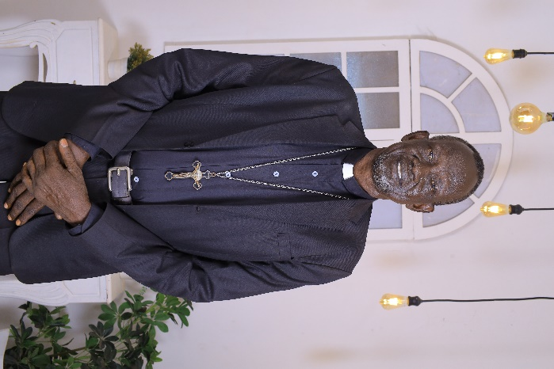
At our January Annual Meeting, we included a new byline in our yearly budget for the support of Pastor Mawien Ariik and his congregations in South Sudan. Pastor Mawien is a 62-year-old native of South Sudan. In 2002, he was ordained in the ELCA after having attended Luther Seminary. For a brief time, he served in the Minneapolis area but then felt called to return to his home country where he planted three rural congregations: St. Paul’s which was planted in 2013, Little Zion in 2014, and St. John’s in 2018. He also founded a school – St. Paul Lutheran Academy in 2014.

After leaving the ELCA, Pr. Mawien joined the LCMC and is a certified LCMC pastor in good standing. All three of his churches are also now part of the LCMC. While Mawien was part of the ELCA, he received funding, but when that partnership ceased to exist, his ministry to rural South Sudanese began to struggle. This is where we come in.
Pastor Mawien Ariik
South Sudan is a country with a troubled history. While the country has rich agricultural land along the White Nile and plenty of oil reserves, South Sudan has seen its share of civil war. Sudan began as a nation under Egyptian conquest and British colonization with intense division between north and south. In 1956, when Sudan became a nation, the south tried to secede, but failed leading to two civil wars through the years 1955-2005. In 2011, South Sudan finally won its independence from Sudan, but in 2013 complex tribal civil wars broke out. Even today, South Sudan still deals with terrible violence because of tribal factions that stem from the highest offices in South Sudan’s government. This, coupled with famine in 2017 and delayed peace processes, has left many poor.

South Sudan desperately needs the Gospel to break in against corruption, violence, and crime found at every level. Fortunately, there are Christians and preachers present in the country like Pastor Mawien. We may never ourselves step foot in South Sudan, but Christ is there working amongst her people. Let us boldly enter into this partnership with Mawien and his ministry and see what God has in store for South Sudan!

Daily Scripture Readings

“Your word is a lamp to my feet and a light to my path.” Psalm 119:105

Sunday | Monday | Tuesday | Wednesday | Thursday | Friday | Saturday
Feb. 1st  John  4:1-26 | John  4:27-42 | Luke  15:1-7 | Luke  15:8-10 | Luke  15:11-32 | Luke  16:1-13 | John  4:43-45
Feb. 8th  John  4:46-54 | John  5:1-18 | John  5:19-29 | John  5:30-47 | John  6:1-15 | John  6:16-21 | John  8:12-20
Feb. 15th  John  9:1-41 | Matthew  17:1-13 | Luke  12:22-34 | John  10:1-18 | John  10:19-21 | John  10:22-30 | John  10:31-42
Feb. 22nd  John  11:1-44 | John  11:45-57 | John  12:1-11 | John  12:12-19 | John  12:20-36 | John  12:37-50 | Isaiah  6:1-10






Add a little Scripture to your daily routine! Tune in each day on Facebook or YouTube at 8:10 AM Monday through Friday for a short devotion or watch later at your convenience.

Find Peace Wherever You Go!
Follow Peace Lutheran on all our socials. Keep up with the most current announcments, be fed by God’s Word through 8:10 Devotions and Online Bible Study, and never miss worship!
Facebook: facebook.com/peacelutheranlinton
YouTube: youtube.com/@peacelutheran1357
Instagram: instagram.com/peace.lutheran

Online Giving Made Easy
Tithe.ly makes it easy to give either with their app or by clicking the green “Give” button on our church website (ndpeacelutheran.com). Give using your credit card or give directly from your bank account. You can choose to give a onetime gift (“I forgot my checkbook!”) or set your gift up to be recurring (“I never want to carry my checkbook again!”) You can even designate which fund your gift will go to and leave a memo to indicate an honorarium or memorial.

Thrivent Choice Dollars
If you are an eligible Thrivent Financial member and have Choice Dollars® available to direct, please consider directing them to your church. For more info or to direct Choice Dollars, call 800-847-4836 and say “Thrivent Choice” or log go to thrivent.com/thriventchoice.

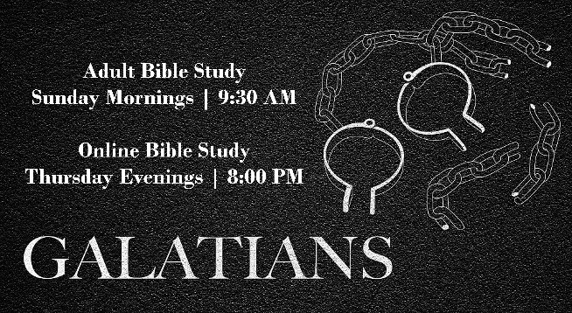
Online Bible Study
Join Pastor Sean with Online Bible Study on our YouTube channel posted on Thursday evenings at 8:00 PM at Youtube.com/@peacelutheran1357

CARILLON “SPECIAL” MUSIC
HONOR SOMEONE WITH FLOWERS

The Flower Committee: Janice Baer and Evelyn Petrick, along with Linton Floral N’ More, has set up a system for members to provide flowers for Sunday Worship Services. For $40, Linton Floral N’ More will provide two arrangements of flowers to be placed in the two vases behind the altar or for $30, a larger single arrangement displayed at the front of the sanctuary.

If you would like to supply flowers for a certain Sunday: Give your money to one of the ladies on the Flower Committee. Specify the date you would like flowers displayed let them know the special occasion and how that info should be listed in the bulletin.


Would you like to honor or remember someone or some event with a song played on the carillons? If so, let the church office know the date and song you would like played (if available). It will be played on that date, and you may choose the time either: 9:30 a.m. or 12:30 p.m. or 6:30 p.m. The song and donor will be acknowledged in the bulletin. The cost for Special Music is a donation.


Please take a moment to check the white board set up in the Narthex and see which Sunday works for you to be an Usher, Reader, Greeter, or Acolyte. Sign up for a whole month or just a Sunday. Volunteers are needed each Sunday.


Need a Ride?
If you need a ride to worship? Please call
Elwin Nieuwsma: 254-0167

If you or anyone you know would like a weekly church bulletin or a monthly newsletter mailed to them, please let the Church Office know. The deadline for the newsletter is the 20th of the month! Please get your news and upcoming information to the church office by that date!
Peace Lutheran Church Mission Statement
Mission of the Month
In December, our congregation sent $782 to Ministry on the Margins. Thank you for your faithful giving.

WELCOME people in
Help them GROW
Send them out to CARE

Welcome ~ Grow ~ Care
Mission of the Month


The Soup Café is a ministry of serving the poor and needy with dignity and respect. The Soup Café is a soup kitchen that is set up as a restaurant where people are welcome to escape the cold and receive a meal free of charge. Each day two homemade soups, two sandwiches, salad bar, desert and beverages are offered free of charge. Patrons can eat as much as they want as long as they don't waste food. No one goes away hungry.

The Soup Cafe is not just for the homeless population. They serve a wide variety of people including the elderly, low income, working poor, disabled, single moms or dads with children, veterans, neighborhood after school kids, ordinary people who just want fellowship and individuals from group homes like HIT or Pride. They provide the Bismarck/Mandan area with a safe place for anyone to come for good food and fellowship.


Country of the Month: Italy

This month the Winter Olympic Games will take place in Milano Cortina, Italy. So why not pray for Italy as you cheer on the USA!?

This great nation contributed much to the world through its legal systems (Roman law), language (Latin), culture (Renaissance, art, music), and innovation (fashion, cars). But the country struggles with financial troubles and organized crime. Networks such as the Sicilian Mafia, Neapolitan Camorra, and now the powerful Calabrian ‘Ndrangheta influence local and federal governments, and every level of society. Pray for courageous people who will oppose this criminal system which hurts the Italian economy. Pray for Christians to live out Kingdom values when they face difficult decisions.

There are signs of hope. Glimmers of hope, however, need to be earnestly prayed for:
- Cooperation among churches. Division and polarization have been the legacies of Protestantism, but things are beginning to change. Several different church networks are beginning to foster trust, respect and even collaboration across the denominational divide.
- Immigration of believers into Italy - particularly from Eastern Europe and Africa but also from Latin America and Philippines - infuses new vitality and openness into the churches, and it opens Italians' eyes to the needs on their doorstep and abroad. Pray that this new reality might spur indigenous churches to greater faith, cooperation and good works.

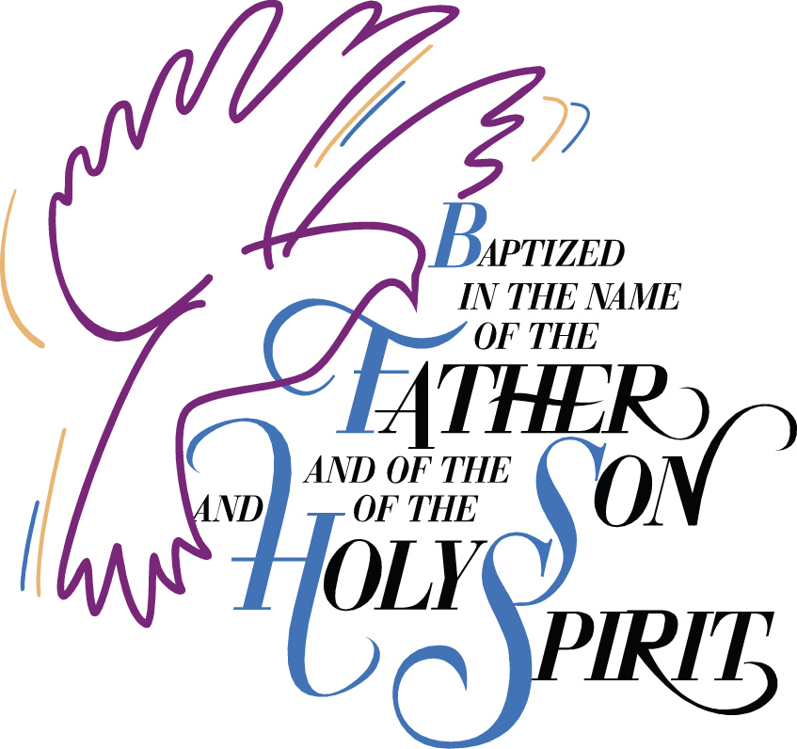

February Birthdays
1 | Brody Rindelaub
 | Henry Stuckle
2 | Keith Ohlhauser
3 | Jaden Bosch
 | Jamie Huber
 | Emsley Randle
4 | Christopher Brueckner
5 | Julia Barnhart
 | Eric Grenz
6 | Melissa Knoepfler
7 | Elsie Barnhart
8 | Albert Weber
10 | Shirlene Serr
 | Eric Vetter
11 | Rick Bosch
12 | Joyce Lemer
13 | Julie Tveito
14 | Holden Nieuwsma
 | Theo Peterson
15 | Lillie Wohl
16 | Janell Huber
 | Ryan Hoff-Wald
19 | Cooper Anderson
22 | Mia Caruso
 | Jessica Schlosser
23 | Elijah Barnhart
 | Walker Staigle
24 | Melissa Fisher
 | Kristi Slater
25 | Jayme Baker
26 | Lorraine Schatz
27 | Ashley Hanson
 | Bob Lester

“For you formed my inward parts; you knitted me together in my mother's womb. I praise you, for I am fearfully and wonderfully made.”
Psalm 139:13-14

February Baptismal Celebrations
7 | Bryan Schatz
8 | Darren Tveito
9 | Olivia Peterson
 | Walker Staigle
10 | Eliza Fisher
11 | Rick Bosch
13 | Keith Ohlhauser
14 | Wade Huber
15 | Iris Bosch
 | Jacob Janacek
16 | Melissa Knoepfler
 | Linda Tschritter
18 | Jessica Schlosser
 | Melvin Wohl
21 | Lavonne Erickson
 | Thomas Vander Vorste
23 | Mia Caruso
24 | Jill Rowe
26 | Twyla Schiermeister
27 | Bailey Huber

